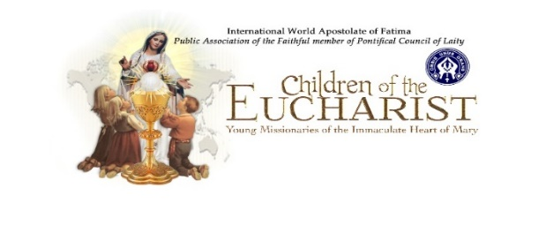
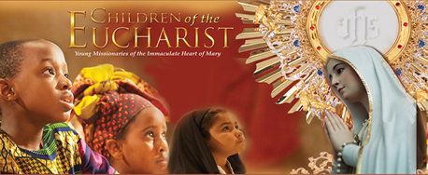

CHILDREN AND YOUTH OF WORLD URGED TO OFFER PRAYERS FOR PEACE
Antonia Salzano, mother of Blessed Carlo Acutis, joins call to prayer on May 13; new song teaches entrustment to children.
Contact: Connie Schneider
www.childrenoftheeucharist.org
Email- connie956@gmail.com
Maureen Wong
Email - Maureen09@gmail.com
May 13 - 2022

Saint Paul, Minnesota: On the Feast of Our Lady of Fatima, May 13, children and youth around the world are invited to join their voices in prayer for peace through entrustment to the Immaculate Heart of Mary.

Internationally acclaimed Catholic recording artist Anna Nuzzo has adapted the Children’s Entrustment Prayer to the Immaculate Heart of Mary, originally written by Children of the Eucharist, to a song that is already resonating with young people and adults all over the globe.

Supporting this international effort is Antonia Salzano, mother of Blessed Carlo Acutis, who has joined her voice to the call for children and young people of the world to spiritually unite in prayer and song.

Salzano, whose son was beatified by Pope Francis in 2020 just 14 years after his death from leukemia, will appear in two videos available on Children of the Eucharist’s website (childrenoftheeucharist.org). One video will be a call for the prayers of children and young people to unite with those prayers of her song Blessed Carlo and Saints Francisco and Jacinta Marto another will be geared toward teachers and parents. The videos will also be available on YouTube.

Participation in this worldwide day of prayer can be done in a variety of ways, ideally through a simple hour of prayer before the Blessed Sacrament. Other ways to participate can include the praying of the Rosary for peace and the saying of the Children’s Entrustment Prayer or the performance of the adapted song (sheet music and more resources are available for free at Nuzzo’s website, annanuzzo.com).

“Children and adults alike love it,” said Connie Schneider, President of Children of the Eucharist, of Nuzzo’s song. “It has the ability to resonate joy throughout the world, singing this gift of entrustment to our Immaculate Mother.” (Watch at https://www.youtube.com/watch?v=lr254EsLHIA)

For more information about entrustments for families, youth and children, visit Children of the Eucharist’s website.

“We humbly ask everyone who has the souls of our children and young in their care to introduce to them the Entrustment prayer and song,” said Schneider. “Help send this prayer from our children and young people as a plea to the Queen of Peace. Prayerfully ask her intercession to put an end to the atrocities in Ukraine and to bring peace to all families and to the whole world.”

“The children at Saint Josaphat at Catholic elementary school in Toronto, Canada, with no practice sang this entrustment song with all of their hearts. Teacher, Halyna Danko, said they are offering it up as a prayer for all the families and children in Ukraine.

They love the refrain, “I am not afraid, because you are always with me.” These were the first words spoken by Our Lady of Fatima to the shepherds of Fatima, “Do not be afraid.”
https://drive.google.com/file/d/1RzKO2gR4l1US-KatSLVHYtAdvZbvJOcN/view

“Let us unite and invite the children and young people of the world to spiritually unite during the month of May but especially on May 13th, 2022, to pray for Peace in our world, families and all humanity,” said Américo López-Ortiz, International President of the World Apostolate of Fatima.

Please consider presenting this Entrustment Prayer Song to choirs, schools and parishes of children and young people of other languages.
Please forward to GINO MARCUZZI gino.marcuzzi@rogers.com a recording to possibly create a collage of the world of our young at prayer to the Immaculate Heart of Mary.
.
Children of the Eucharist, Young Missionaries of the Immaculate Heart of Mary is under the auspices of the International World Apostolate of Fatima, a Public Association of the Faithful.
Save the Date ~ October 13th ~ 2022 19th annual Worldwide Children’s Eucharistic and Marian Holy Hour

