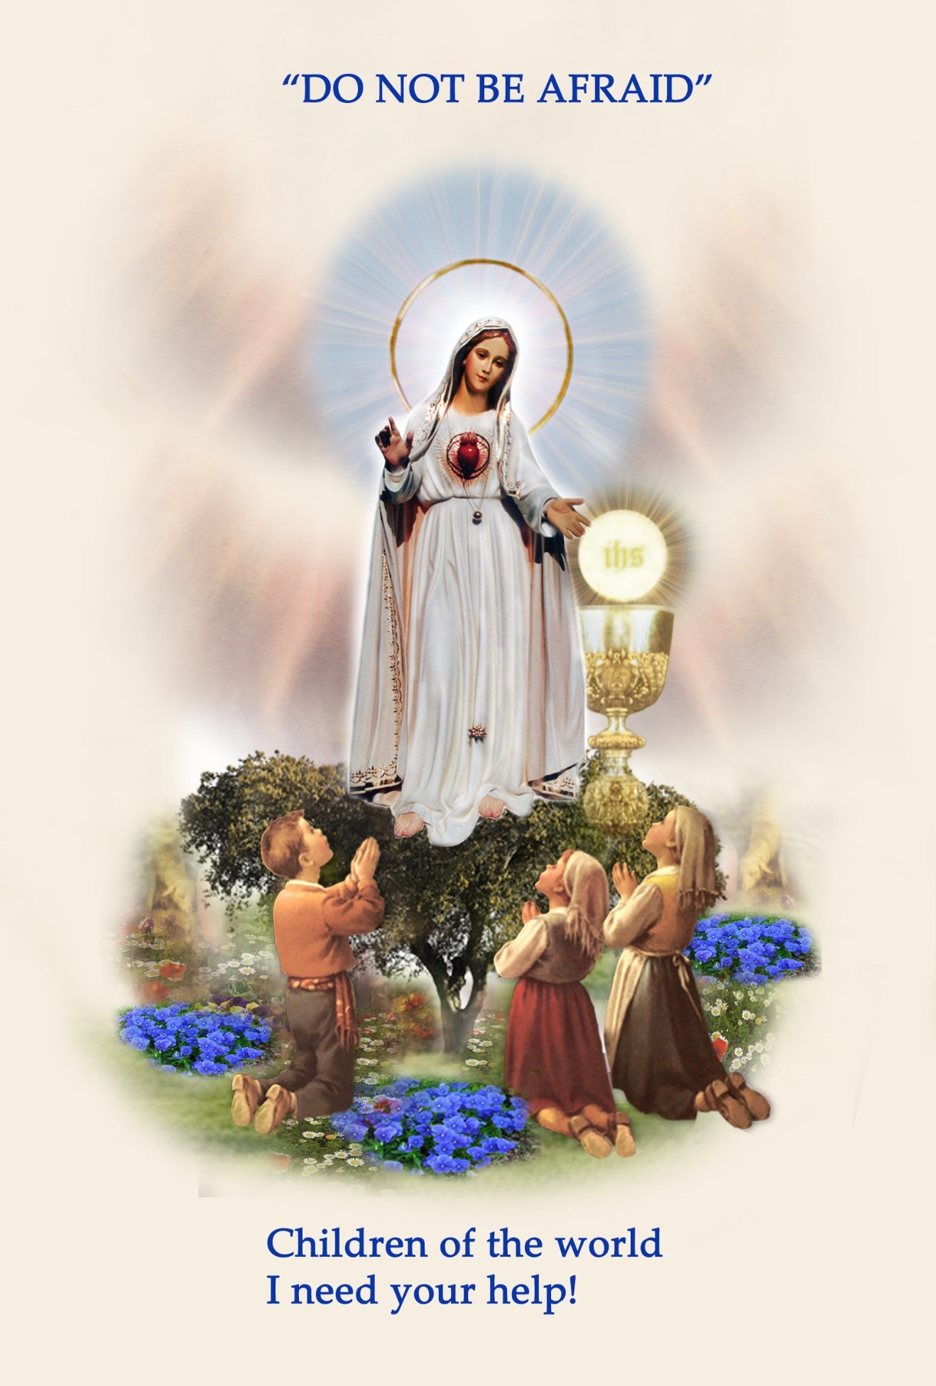

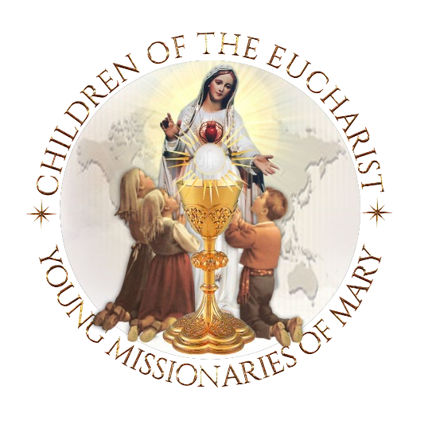

Our Lady of Fatima’s

**19th annual**

# Worldwide Children and Youth Eucharistic and Marian

# Holy Hour

**One Day, One Hour, One Million Children Praying**

PARISHES ~ SCHOOLS ~ FAMILIES

***Clergy ~ Principals ~ Teachers ~ Parents***

***Gather your students and children before Jesus in the Most Blessed***

***Sacrament, in their own parish churches and chapels to***

***‘Console the Sacred Heart of Jesus’ and to pray for PEACE In our Families and World.***

Welcome and Introduction

Moderator - Priest - Deacon - Teacher – Parent

Welcomes the children and those present to the purpose and graces received from the Worldwide Children's Eucharistic Holy Hour.

**Dear Boys and Girls,**

## Highlight the message of Our Lady of Fatima

Our Lady of Fatima sent an Angel from Heaven as a 'teacher of love' to teach the three Little Shepherds of Fatima prayers to pray while in the Presence of Jesus, and to ask them to make sacrifices to console the Sacred Heart of Jesus, Who is so offended because of the many sins in the world.

Boys and Girls, Our Lady of Fatima needs your/our help to bring peace to the world.

So today is a very special day because it is your/our day! It is a day when children and young people throughout the world are gathered before Jesus, truly present in the Holy Eucharist, in large cities and in small villages, on all of the five continents of the world: Africa, the Americas, Europe, Oceania, and Asia.

You are all united with Saint Francisco and Saint Jacinta Marto, the two Little Shepherds of Fatima who are now in Heaven, to console Jesus, and together pray for Pope Francis and your own family and all the families of the world, a mission entrusted to you by Saint John Paul II.

Let us ask the Immaculate Heart of Mary, who is Jesus' mother and our spiritual mother, to present our prayers to Him today!" CANDLE OF UNITY ***and the*** OFFERING OF PETITIONS

The Candle of Unity is lit as a *'symbol of unity'* for children and young people who are spiritually united throughout the world today!

**Immaculate Heart of Mary,** our Most Holy Mother, today we are lighting this 'Candle of Unity,' as a symbol of our 'prayerful unity' with all the children of the world who are gathered before your Divine Son Jesus, truly Present in the Most Blessed Sacrament. Please present our petitions before Jesus and pray to the Holy Spirit that he may descend upon the children of the world and intercede for our families, countries and the world.

Immaculate Heart of Mary, our Mother, pray for us!

OPENING PRAYERS

**Leader:**

**Jesus, I have come to console You, truly present in the Most Blessed Sacrament!**

|  |  |  |
| --- | --- | --- |
| In the Name of the FATHER, and of the SON, and of | |  |
| |  | | --- | | the HOLY SPIRIT. Amen**.** | |  |
| PRAYERS OF ADORATION AND PRAISE |

***All:*** O Sacrament Most Holy! O Sacrament Divine!

All praise and all thanksgiving be every moment Thine!

***(Pray three times)***

***All:*** O MOST HOLY TRINITY, I love You! My God, My God,

I love You in the Most Blessed Sacrament!

***(Pray three times)***

**PRAYERS TO THE HOLY SPIRIT!**

**Come Holy Spirit, Come upon all the Children of the World!**

**(*Pray three times)***

***Leader: Let us offer a prayer to call upon the Holy Spirit!***

***All:***

**COME HOLY SPIRIT,**

Come by means of the powerful intercession of the Immaculate Heart of MARY, Your well-beloved Spouse!

**COME HOLY SPIRT,**

Descend upon all the Families of the world! **COME HOLY SPIRIT,**

Descend upon all of the Children of the world.

PRAYERS OF REPARATION

***Leader:***

The Angel of Peace taught the Little Shepherds

prayers to console Jesus in the

Holy Eucharist.

Let us bow our heads and pray the prayers of reparation as taught to the

Little Shepherds at Fatima, by the Angel of Peace.

All:

THE PARDON PRAYER

My God, I believe, I adore, I hope, and I love Thee!

I beg pardon for those who do not believe,

Do not adore, Do not hope, and

Do not love Thee!

***(Pray three times)***

**PRAYER OF REPARATION**

**Leader:**

The Third time the Angel of Peace visited the Little Shepherds, he taught them a very special prayer, called the Prayer of Reparation.

"O MOST HOLY TRINITY,

FATHER, SON AND HOLY SPIRIT,

I adore Thee profoundly.

I offer Thee the most precious

Body, Blood, Soul and

Divinity of JESUS CHRIST,

Present in all the Tabernacles of the world, in reparation for the outrages, Sacrileges and indifference by which He is offended.

By the infinite merits of the Sacred Heart of Jesus and the Immaculate Heart of Mary

I beg the conversion of poor sinners."

***(Pray one time)***

Three minutes of Silence

**Children rest in the Holy Presence of Jesus**

PRAYER ***to* SAINT FRANCISCO AND SAINT JACINTA MARTO**

**FOR AN END TO THE PANDEMIC**

PRAYER TO SAINT JACINTA ANDSAINT FRANCISCO MARTO FOR THIS TIME

Saints Jacinta and Francisco Marto, dear shepherd children of Fatima, you were chosen by Heaven to see Our Blessed Motherand to deliver her message of conversion to a world that hadstrayed far from God.You who suffered so greatly and died from Spanish flu, thepandemic of your time, pray for us who suffer in the pandemicText, letter
of our times, that God may have mercy upon us.PRAY FOR THE CHILDREN OF AMERICA AND WORLDPray for our protection and an end to what plagues usphysically, mentally and spiritually.Pray for our world, the Church, our countries, and for themost vulnerable people who are suffering and in need of healing.Little Shepherds of Fatima, help us to come to the refuge ofMary’s Immaculate Heart, so to receive the graces we need at this time, and to come to the beauty of the life that is to come.

My Entrustment to the Immaculate

Heart of Mary

“O Virgin Mary,

My Mother,

I give to Your Immaculate Heart, my body and my soul, my thoughts and my actions.

I want to be just what You want me

to be and do just what You want me to do.

I am not afraid because You are always with me.

Help me to love your Son Jesus, <https://childrenoftheeucharist.org/shop>

with all my heat and above all things

Take my hand in Yours, so I can always be with you. Amen

CROWNING OF OUR LADY'S IMAGE - OPTIONAL

Child Presentation of the Crowning of Our Blessed Mother

Immaculate Heart of Mary, our Mother,

The children of the world pray:

“Heavenly Father, to You we offer praise and thanksgiving, because what You have kept hidden from the proud and learned, You have revealed to us the merest of children.

Thank You Father, for You have graciously willed it so.

Heavenly Father, today children are united in prayer before the

Most Blessed Sacrament throughout the world, to pray for their family and country.

We would like to take this opportunity to thank you for sending our Blessed Mother Mary to Fatima,

Portugal, to three young children. Because it was there that heaven entrusted a message of hope and a simple *Plan for Peace*, for the whole world... to children.

Dear Mother Mary, at Fatima you told Lucia, Blessed Francisco, and Blessed Jacinta, that “God wishes to establish devotion to my Immaculate Heart in the world.”

Dear Mother, we the children of the world want to help you bring the world back to God!

We ask you to draw the children of the world into the depths of the Heart of Jesus who is truly present in the Blessed Sacrament, to pray for our Holy Father Pope Francis, our priests, families, country and the world.

So today, as a sign of our petitions and of our promise to help you bring the world back to God, we crown this beautiful image you.

(Crowning Child holds the crown up for all to see and says :

Immaculate Heart of Mary, Queen of Families, *pray for us*

Immaculate Heart of Mary, Queen of the Clergy, *pray for us*

Immaculate Heart of Mary, Queen of Peace, *pray for us*

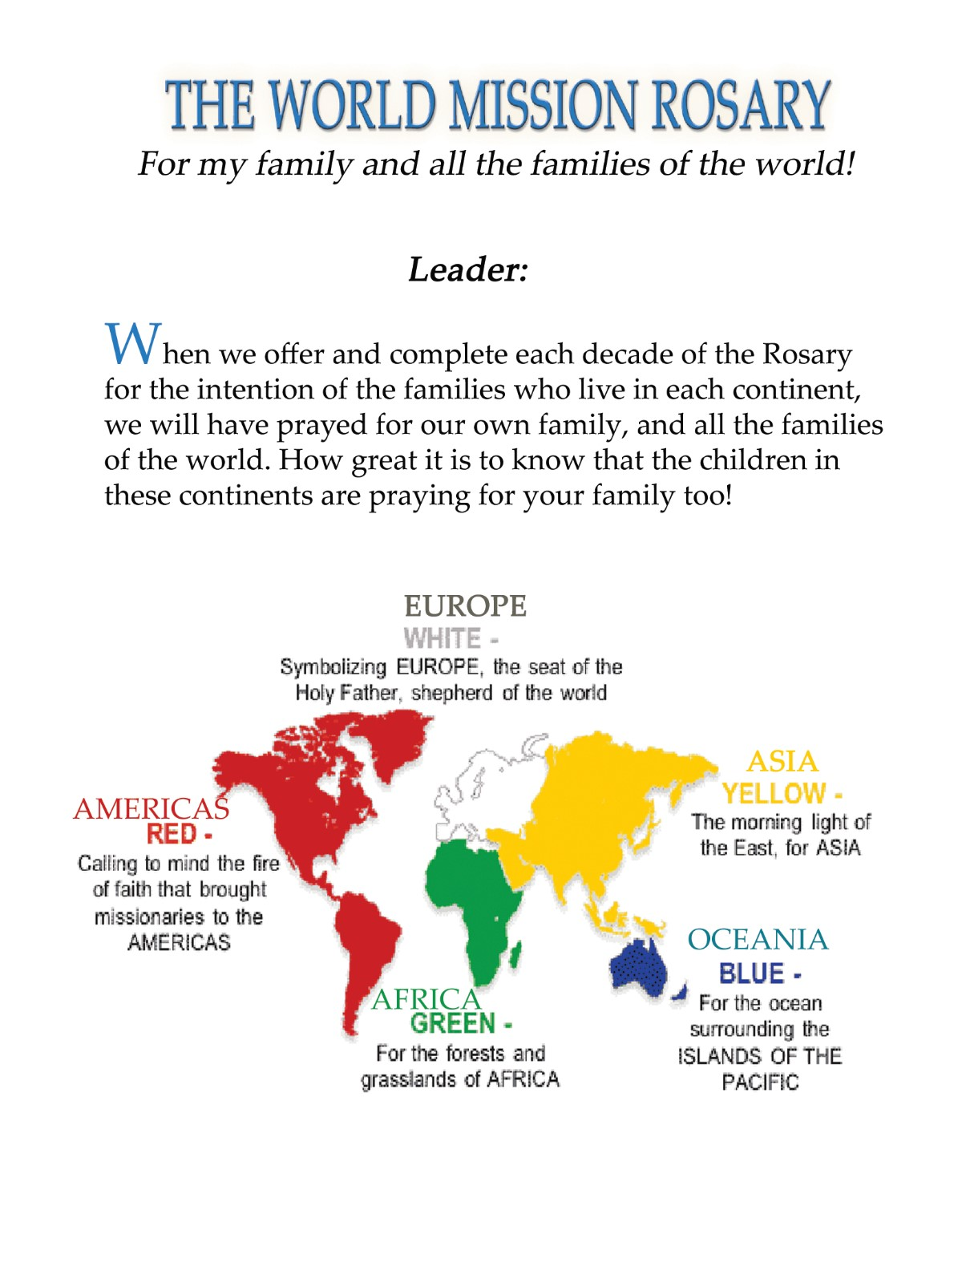

## Children of the world pray the rosary

## You can change the sorrowful mystery pictures below with the Joyful, Glorious or luminous on the world rosary page.

## [https://childrenoftheeucharist.org/children-pray-the-rosary/](%20https:/childrenoftheeucharist.org/children-pray-the-rosary/)

The Sorrowful Mysteries of the rosary

For pope Francis for peace in our Families, FOR LIFE

AND THE TRIUMPH OF THE IMMACULATE HEART OF MARY.

You can change out the mysteries of the rosary for the day of your prayer or holy hour. Find them here: [https://childrenoftheeucharist.org/children-pray-the-rosary/](https://childrenoftheeucharist.org/children-pray-the-rosary/%20%20)

WORLD MISSION ROSARY

Child leading the Rosary:

“Blessed Mother, at Fatima you said, “Pray your Rosary every day to obtain peace in the world.” We, the Children of the World, are united in prayer today as we pray the Most Holy Rosary for our Holy Father, and for peace in our families and in the world.

“We are the children of the world, praying for Pope Francis, and peace in our families and the world.

### 1st Sorrowful Mystery

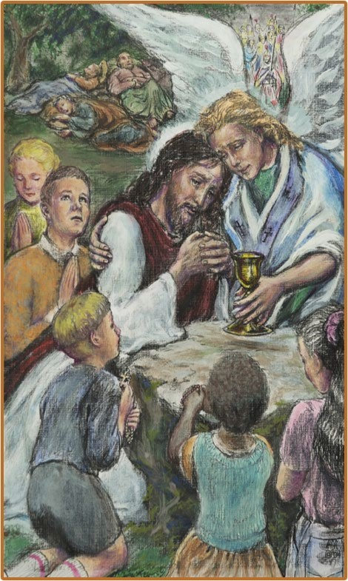AFRICA

**“The 1st Sorrowful Mystery – The Agony of Jesus in the Garden.”**

**Fruit of the Mystery – Sorrow for**

#### Sin

“We are the children of the world, praying for Pope Francis, priests, and peace in our families and the world.

In this First Decade, we recall to mind the priests and families of Africa that they may grow in the

**Virtue of Hope**.”

Our Father… 10 Hail Mary's… Glory be… Fatima Prayer…

AVE, AVE, AVE, Maria...

### 2nd Sorrowful Mystery

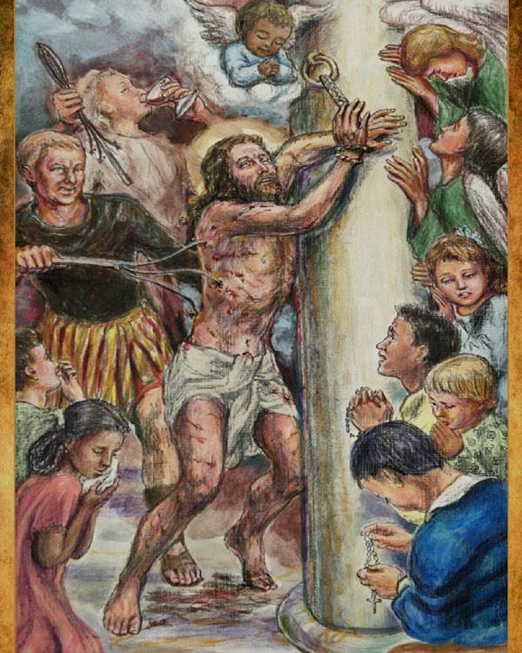

AMERICAS

**“The 2nd Sorrowful Mystery - The Scourging of Jesus at the**

**Pillar.”**

**Fruit of the Mystery - Purity**

“We are the children of the world, praying for Pope Francis, and peace in our families and the world.

In this Second Decade, we recall to mind the priests and families of the Americas that they may grow in their

Love for God and for one another.” Our Father… 10 Hail Mary's… Glory be… Fatima Prayer…

AVE, AVE, AVE, Maria...

### 3rd Sorrowful Mystery

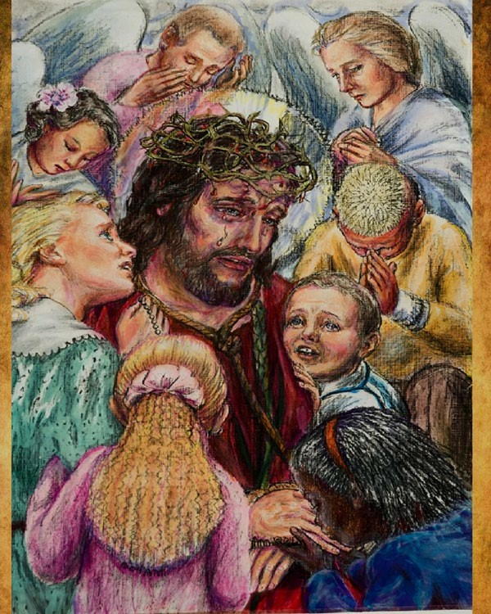**EUROPE – Pope Francis**

**“The 3rd Sorrowful Mystery: Jesus is crowned with Thorns.”**

Fruit of the Mystery - Courage

“We are the children of the world, praying for Pope Francis, and peace in our families and the world.

In this Third Decade, we recall to mind the priests and families throughout Europe that they may grow in purity of mind, body and soul.”

Our Father… 10 Hail

Mary's… Glory be… Fatima Prayer…

AVE, AVE, AVE, Maria...

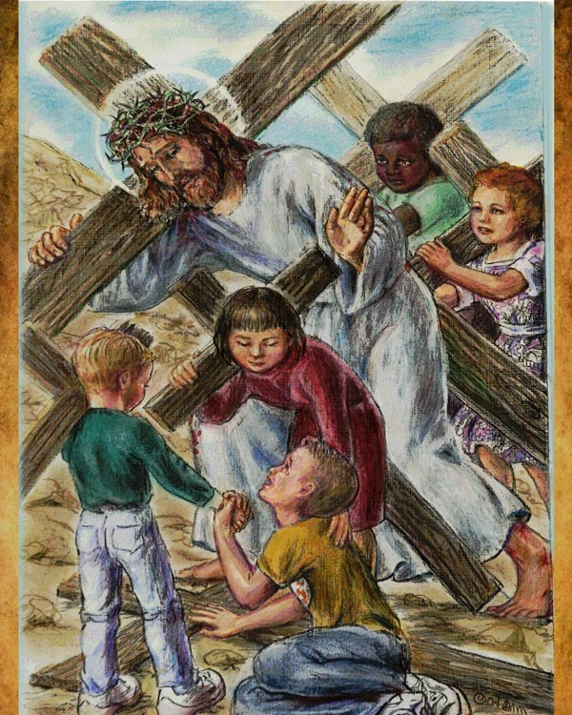**4th Sorrowful Mystery**

**OCEANIA -**

**The fruit of the mystery -**

**Patience**

**“The 4th Sorrowful Mystery:**

**Jesus Carries His Cross.”**

“We are the children of the world, praying for Pope Francis, and peace in our and families and the world.

In this Fourth Decade, we recall to mind, the priests and families of Oceania, that they may grow in their love for the Immaculate Heart of

Mary.” Our Father…10 Hail Mary's… Glory be…Fatima Prayer

AVE, AVE, AVE, Maria...

### 5th Sorrowful Mystery

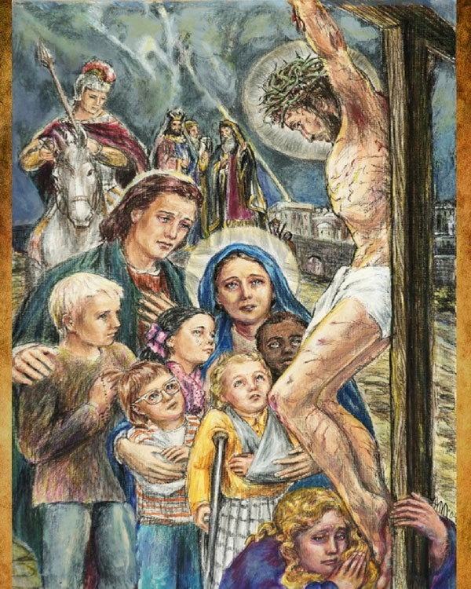**ASIA -**

**“The 5th Sorrowful Mystery: The**

**Crucifixion and Death of Jesus.”**

**The fruit of the Mystery -**

**Perseverance**

“We are the children of the world, praying for Pope Francis, and peace in our families and the world. In this Fifth Decade, we recall to mind the priests and families throughout Asia

that they may grow in holiness.”

Our Father… 10 Hail Mary's… Glory be… Fatima Prayer…

AVE, AVE, AVE, Maria...

Closing prayers of the Most Holy Rosary...

Thank you for participating in the 12th annual, Worldwide Children's Eucharistic Holy Hour.

***Please begin a Little Shepherds Holy Hour in your parish, school and family.***

In the Immaculate Heart of Mary

The International World Apostolate of Fatima

Board of Trustees of Children of the Eucharist, Young Missionaries of the Immaculate Heart of Mary: our prayer is that the souls of the children in your care will become active missionaries of the Immaculate Heart of Mary in their parishes, schools and families.

IMPRIMATUR: Most Reverend Bishop Antonio Marto of Leira-Fatima - Portugal

February 20, 2012

#### Rite for the Blessing and Investiture of the Scapular of Our Lady of Mount Carmel

To obtain the fullest possible benefits from the Brown Scapular devotion, one must be validly invested (sometimes called "enrolled") in the Brown Scapular by a priest who possesses the faculties (usually a Carmelite, Dominican or Franciscan), using a scapular blessed by the same or any other priest. After proper enrollment in the Scapular, a person need not have subsequent scapulars blessed. Once enrolled you are enrolled until death.

A Scapular Ritual for Priests, with the prayers of enrollment, is found below:

Priest - Show us, O Lord, Thy mercy.

Respondent - And grant us Thy salvation.

P - Lord, hear my prayer.

R - And let my cry come unto Thee.

P -The Lord be with you.

R - And with your spirit.

P - Lord Jesus Christ, Savior of the human race, sanctify by Thy power these scapulars, which for love of Thee and for love of Our Lady of Mount Carmel, Thy servants will wear devoutly, so that through the intercession of the same Virgin Mary, Mother of God, and protect against the evil spirit, they persevere until death in Thy grace. Thou who liveth and reigneth world without end. Amen.

The Priest does the Aspersion and Invests Person(s) While Saying:

Receive this blessed Scapular and ask the Most Holy Virgin that by Her merits, it may be worn with no stain of sin, protect you from all harm and bring you to everlasting life. Amen.

After the Investiture the Priest Continues With the Prayers:

I, by the power vested in me, admit you to participate in all the spiritual benefits obtained through the mercy of Jesus Christ by the Religious Order of Mount Carmel. In the name of the Father+and of the Son+and of the Holy Ghost+. Amen. May God Almighty, the Creator of Heaven and earth, bless you, He who has deigned to join you to the confraternity of the Blessed Virgin of Mount Carmel; we beseech Her to crush the head of the ancient serpent so that you may enter into possession of your eternal heritage through Christ our Lord.

#### Investiture of the Medal of the Immaculate Conception

“Have a Medal struck according to this model, those who wear it after being blessed shall receive great graces, especially if they wear it around their neck. Graces will be abundant for those who have confidence. "

Our Lady to St. Catherine Laboure

November 27th ~ 1830

Priest: Our help is in the name of the Lord.

Response: Who made heaven and earth. Priest: The Lord be with you.

Response: And with thy spirit.

Let us pray.

Almighty and merciful God! In virtue of the many apparitions on earth of the

Immaculate Virgin Mary, it has pleased thee to work miracles again and again for the salvation of souls. Be thou gracious and pour out Thy blessing X upon this medal, so that all who piously reverence it and devoutly wear it may experience the patronage of Mary Immaculate and obtain mercy from thee. Through Christ our Lord. AMEN

Then he sprinkles the medal with Holy water and presents it to the person saying:

Receive the holy medal, wear it with faith, and handle it with becoming devotion, so that the most Holy and Immaculate Queen of Heaven may protect and defend thee. And as she is ever ready to renew her wondrous acts of kindness, may she obtain for thee in Her mercy whatsoever thou dost humbly ask of God, so that both in life and in death thou canst rest securely in her motherly embrace. Amen.

He continues:

Lord, have mercy on us. Christ have mercy on us. Lord, have mercy on us.

Our Father

Priest: And lead us not into temptation.

Response: But deliver us from evil.

Priest: O Queen conceived without original sin.

Response: Pray for us.

Priest: O Lord, hear my prayer

Response: And let my cry unto thee.

Priest: The Lord be with you.

Response: And with thy spirit.

Let us pray.

O Lord Jesus Christ, Who hast willed that thy Mother, the Blessed Virgin Mary conceived without sin shou made illustrious through countless miracles, do thou grant that we who constantly invoke her patronage ma come to possess everlasting joys. Who livest and reignest throughout endless ages. AMEN