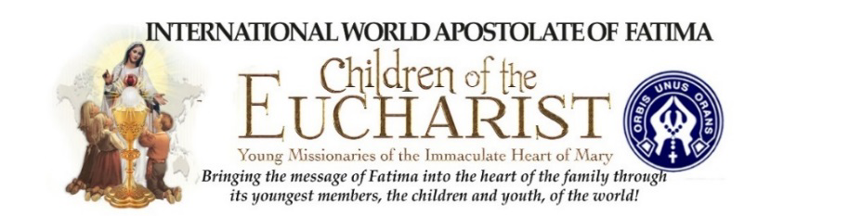

EWTN to Broadcast 16th annual Worldwide Children’s
Eucharistic and Marian Holy Hour
at 10 a.m. E.T. on October 5th, to over 140 nations.

All Catholic School children and all children of the world are invited to pray the Rosary before the Blessed Sacrament on October 5th, 2018

Williamsville, New York On First Friday, October 5th, Father Chris Alar, MIC, of the Marians of the Immaculate Conception and Director of the Association of the Marian Helpers, will preside over the 16th annual Worldwide Children’s Eucharistic Holy Hour. In Father’s video invitation https://youtu.be/LmkIJBs4P-Q he invites our Catholic School Principals, Teachers, Parents and Grandparents, to help gather one or a thousand children into their parish church or chapels to spiritually unite the prayers of their own children and students with the Catholic school students at Saint Gregory the Great Parish and throughout the world.

Our world is in crisis and the children can help. Your children are invited to Adore Jesus in the Blessed Sacrament, Pray the Rosary, Chaplet of Divine Mercy, and Entrust their lives to the most tender of mothers, our mother Mary, as prayers are offered for our Holy Father, priests, victims of every kind of abuse, and the families of the world.

“It is my hope that one day we will help our children to take their rightful place as Our Lady of Fatima’s powerful intercessors and missionaries of her Immaculate Heart. We hope the children will send a nice note to their pastor that they prayed for him.”
Mrs. Connie Schneider
President of Children of the Eucharist, Young Missionaries of the Immaculate Heart of Mary

The International World Apostolate of Fatima’s Children of the Eucharist Young Missionaries of the Immaculate Heart of Mary www.childrenoftheeucharist.org offers their very special thanks to the following organizations as they collaborate to gather the children of the world in the prayer of the Most Holy Rosary and Chaplet of the Divine Mercy before the Most Blessed Sacrament.

- EWTN www.ewtn.com
- Marians of the Immaculate Conception, https://www.marian.org
- Mother of Mercy Messengers https://www.thedivinemercy.org/momm/about.php
- OptionC Inc., a Catholic based School and Diocesan Management System, https://www.optionc.com

About Children of the Eucharist
For more information on this mission please visit www.childrenoftheeucharist.org. Please consider making a tax-deductible donation to this 501 ( c ) 3 religious organization.

