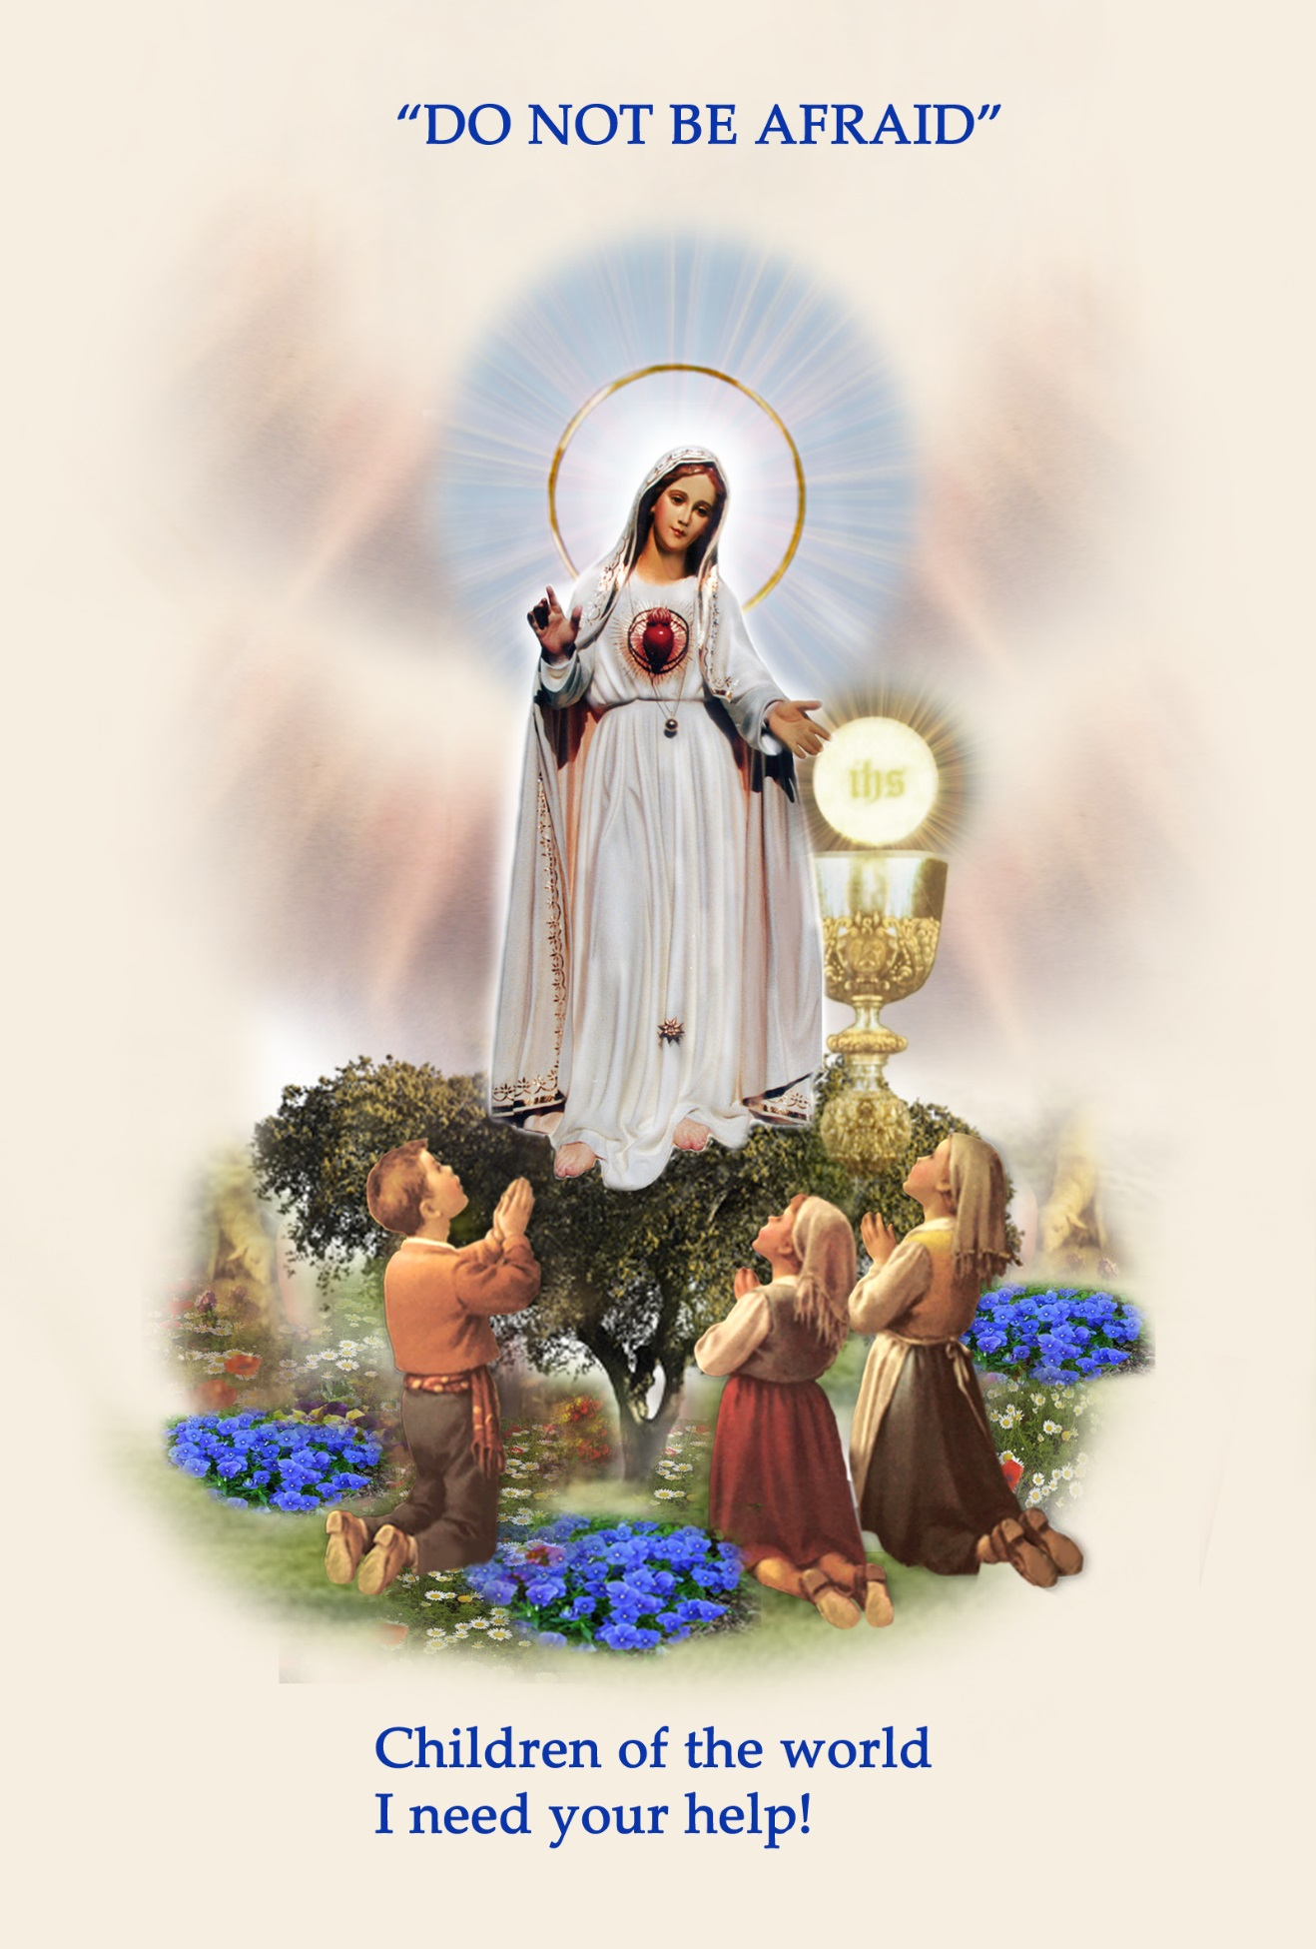
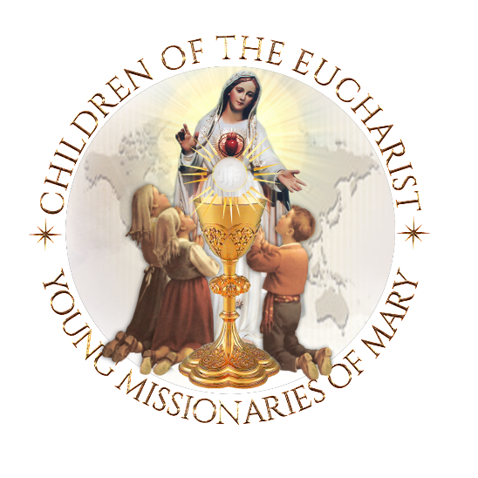

Our Lady of Fatima’s
16th annual
Worldwide Children’s Eucharistic Holy Hour

One Day, One Hour, One Million Children Praying

PARISHES ~ SCHOOLS ~ FAMILIES
Clergy ~ Principals ~ Teachers ~ Parents
Gather your students and children before Jesus in the Most Blessed Sacrament, in their own parish churches and chapels to
‘Console the Sacred Heart of Jesus’ and to pray for PEACE
In our Families and World.

Welcome and Introduction
Moderator - Priest - Deacon - Teacher – Parent
Welcomes the children and those present to the purpose and graces
received from the Worldwide Children's Eucharistic Holy Hour.
Dear Boys and Girls,
Highlight the message of Our Lady of Fatima
Our Lady of Fatima sent an Angel from Heaven as a 'teacher of love' to teach the three Little Shepherds of Fatima prayers to pray while in the Presence of Jesus, and to ask them to make sacrifices to console the Sacred Heart of Jesus, Who is so offended because of the many sins in the world.
Boys and Girls, Our Lady of Fatima needs your/our help to bring peace to the world.
So today is a very special day because it is your/our day! It is a day when children and young people throughout the world are gathered before Jesus, truly present in the Holy Eucharist, in large cities and in small villages, on all of the five continents of the world: Africa, the Americas, Europe, Oceania, and Asia.
You are all united with Saint Francisco and Saint Jacinta Marto, the two Little Shepherds of Fatima who are now in Heaven, to console Jesus, and together pray for Pope Francis and your own family and all the families of the world, a mission entrusted to you by Saint John Paul II.
Let us ask the Immaculate Heart of Mary, who is Jesus' mother and our spiritual mother, to present our prayers to Him today!"

CANDLE OF UNITY and the OFFERING OF PETITIONS
The Candle of Unity is lit as a 'symbol of unity' for children and young people who are spiritually united throughout the world today!
Immaculate Heart of Mary, our Most Holy Mother, today we are lighting this 'Candle of Unity,' as a symbol of our 'prayerful unity' with all the children of the world who are gathered before your Divine Son Jesus, truly Present in the Most Blessed Sacrament. Please present our petitions before Jesus and pray to the Holy Spirit that he may descend upon the children of the world and intercede for our families, countries and the world.
Immaculate Heart of Mary, our Mother, pray for us!

OPENING PRAYERS
Leader:
Jesus, I have come to console You, truly present in the Most Blessed Sacrament!
In the Name of the FATHER, and of the SON, and of the HOLY SPIRIT. Amen.

PRAYERS OF ADORATION AND PRAISE

All: O Sacrament Most Holy! O Sacrament Divine!
All praise and all thanksgiving be every moment Thine!
(Pray three times)

All: O MOST HOLY TRINITY, I love You!
My God, My God,
I love You in the Most Blessed Sacrament!
(Pray three times)

PRAYERS TO THE HOLY SPIRIT!
Come Holy Spirit, Come upon all the Children of the World!
(Pray three times)
Leader: Let us offer a prayer to call upon the Holy Spirit!
All:
COME HOLY SPIRIT,
Come by means of the powerful intercession of the
Immaculate Heart of MARY, Your well-beloved Spouse!
COME HOLY SPIRT,
Descend upon all the Families of the world!
COME HOLY SPIRIT,
Descend upon all of the Children of the world.

PRAYERS OF REPARATION
Leader:
The Angel of Peace taught the Little Shepherds prayers to console Jesus in the
Holy Eucharist.
Let us bow our heads and pray the prayers of reparation as taught to the
Little Shepherds at Fatima, by the Angel of Peace.

THE PARDON PRAYER
All:
My God, I believe, I adore, I hope and I love Thee!
I beg pardon for those who do not believe,
Do not adore,
Do not hope, and
Do not love Thee!
(Pray three times)

PRAYER OF REPARATION
Leader:
The Third time the Angel of Peace visited the Little Shepherds, he taught them a very special prayer, called the Prayer of Reparation.
"O MOST HOLY TRINITY,
FATHER, SON AND HOLY SPIRIT,
I adore Thee profoundly.
I offer Thee the most precious
Body, Blood, Soul and
Divinity of JESUS CHRIST,
Present in all the Tabernacles of the world, in reparation for the outrages, Sacrileges and indifference by which He is offended.
By the infinite merits of the Sacred Heart of Jesus and the Immaculate Heart of Mary
I beg the conversion of poor sinners."
(Pray one time)
Three minutes of Silence
Children rest in the Holy Presence of Jesus

PRAYER to SAINT FRANCISCO AND SAINT JACINTA MARTO

Prayer to Saint Francisco and Saint Jacinta Marto
for the families of the world!
Dear Saint Francisco and Saint Jacinta,
The children of the world would like to learn from you how to love
more perfectly.
Saint Jacinta, teach us how to love one another, especially sinners.
Help us to pray and to make sacrifices for those who offend Our Lord
so deeply.
Saint Francisco, teach us your great love for the Sacred Heart of JESUS in the Holy Eucharist, hurt by the ingratitude of so many.
Little Shepherds of Fatima, help me, my family, and all the
families of the world, to seek the safety of the Immaculate Heart
of our Mother MARY, who always brings all of us and our families
closer to Her Son JESUS.
Saint Francisco and Saint Jacinta, pray for us, pray for all the
children and families of the world! Amen

My Entrustment to the Immaculate Heart of Mary
“O Virgin Mary,
My Mother,
I give to Your Immaculate Heart,
my body and my soul,
my thoughts and my actions.
I want to be just what You want me to be, and do just
what You want me to do.

I am not afraid because
You are always with me.
Help me to love your Son Jesus,
with all my heat and above all things
Take my hand in Yours, so I can always be with you.
CROWNING OF OUR LADY'S IMAGE - OPTIONAL
Child Presentation of the Crowning of Our Blessed Mother
Immaculate Heart of Mary, our Mother,
The children of the world pray:
“Heavenly Father, to You we offer praise and thanksgiving, because what You have kept hidden from the proud and learned, You have revealed to us the merest of children.
Thank You Father, for You have graciously willed it so.
Heavenly Father, today children are united in prayer before the
Most Blessed Sacrament throughout the world, to pray for their family and country.
We would like to take this opportunity to thank you for sending our Blessed Mother Mary to Fatima,
Portugal, to three young children. Because it was there that heaven entrusted a message of hope and a simple Plan for Peace, for the whole world... to children.
Dear Mother Mary, at Fatima you told Lucia, Blessed Francisco, and Blessed Jacinta, that “God wishes to establish devotion to my Immaculate Heart in the world.”
Dear Mother, we the children of the world want to help you bring the world back to God!
Today, in this ‘Year of Faith’ we ask you to draw the children of the world into the depths of the Heart of Jesus who is truly present in the Blessed Sacrament, to pray for our Holy Father Pope Francis, our priests, families, country and the world.
So today, as a sign of our petitions and of our promise to help you bring the world back to God, we crown this beautiful image you.
(Crowning Child holds the crown up for all to see and says :
Immaculate Heart of Mary, Queen of Families, pray for us

Immaculate Heart of Mary, Queen of the Clergy, pray for us
Immaculate Heart of Mary, Queen of Peace, pray for us

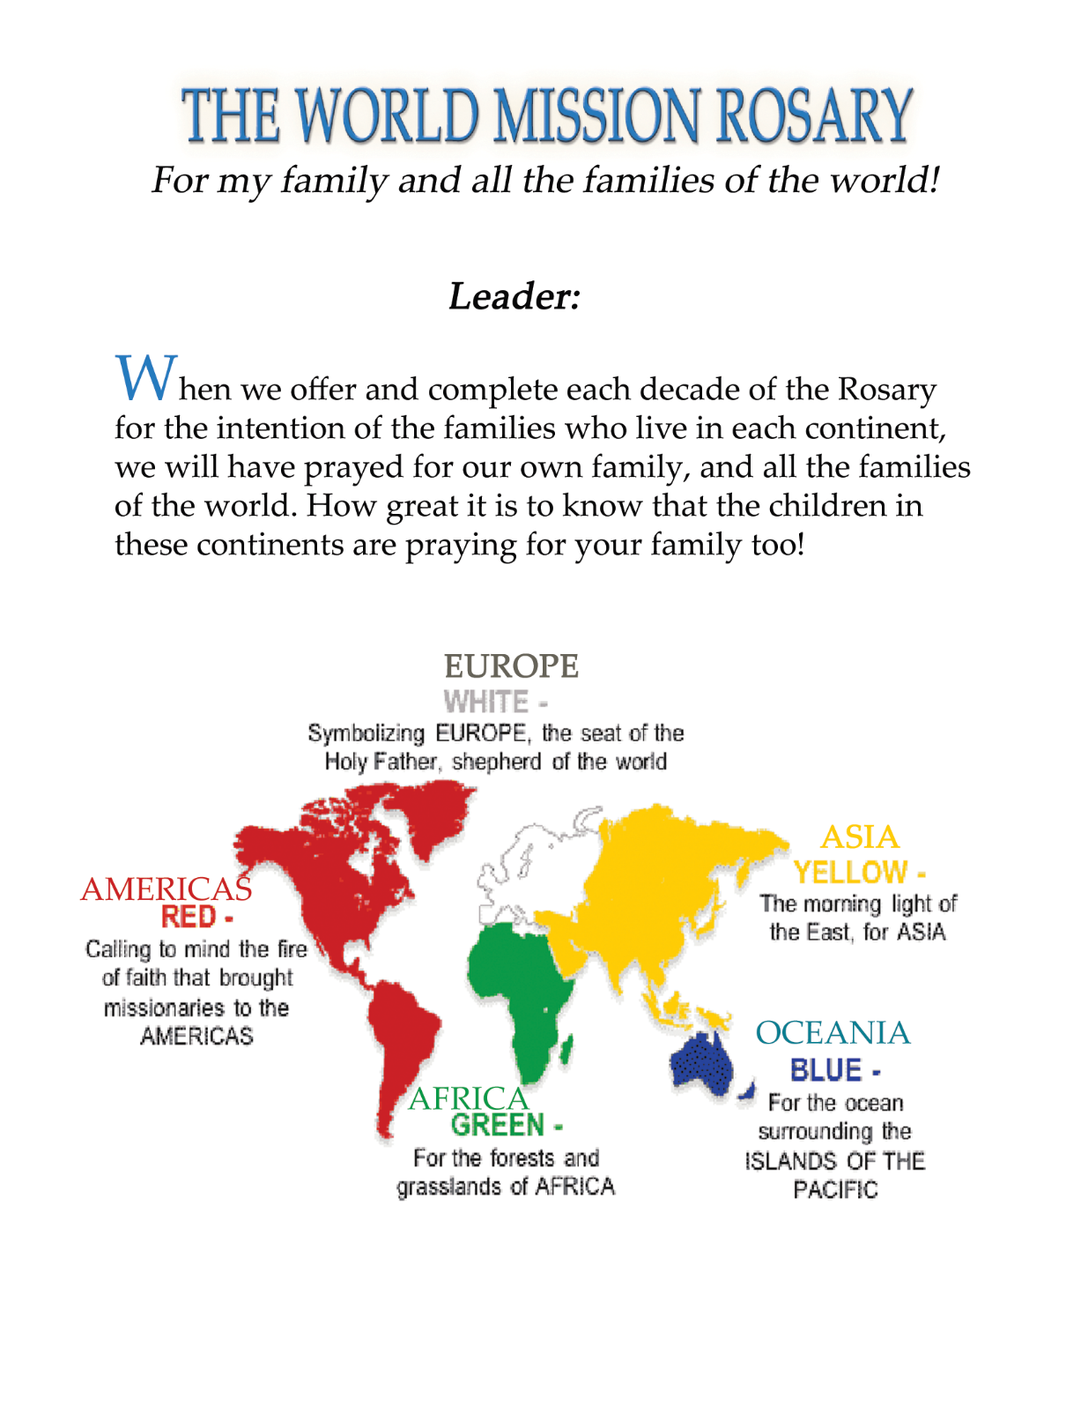

Children of the world pray

The Sorrowful Mysteries of the rosary
For pope Francis, and peace in our Families and the World!

WORLD MISSION ROSARY
Child leading the Rosary:
“Blessed Mother, at Fatima you said, “Pray your Rosary every day to obtain peace in the world.” We, the Children of the World, are united in prayer today as we pray the Most Holy Rosary for our Holy Father, and for peace in our families and in the world.

“We are the children of the world, praying for Pope Francis, and peace in our families and the world.
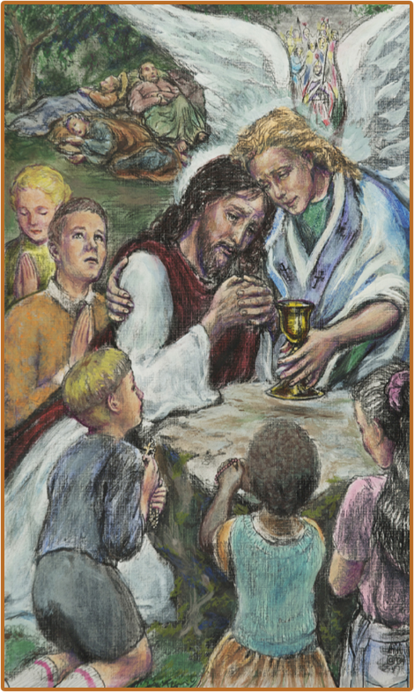
1st Sorrowful Mystery
AFRICA
“The 1st Sorrowful Mystery – The Agony of Jesus in the Garden.”
Fruit of the Mystery – Sorrow for Sin
“We are the children of the world, praying for Pope Francis, priests, and peace in our families and the world.
In this First Decade, we recall to mind the priests and families of Africa that they may grow in the Virtue of Hope.”

Our Father… 10 Hail Mary's… Glory be… Fatima Prayer…

AVE, AVE, AVE, Maria...

2nd Sorrowful Mystery
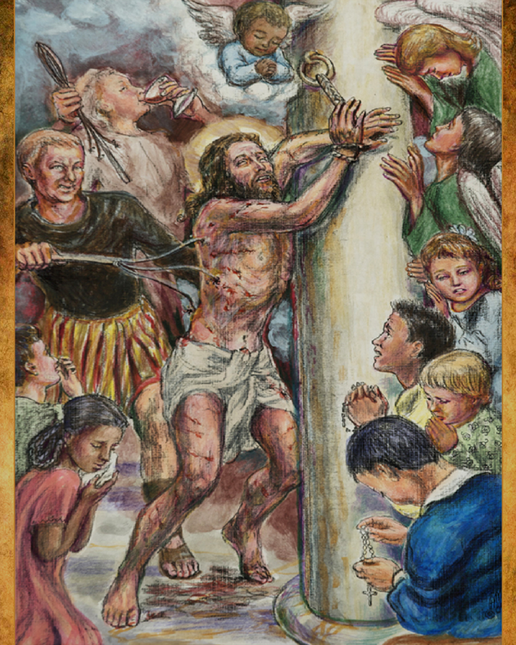
AMERICAS

“The 2nd Sorrowful Mystery - The Scourging of Jesus at the Pillar.”

Fruit of the Mystery - Purity
“We are the children of the world, praying for Pope Francis, and peace in our families and the world.
In this Second Decade, we recall to mind the priests and families of the Americas that they may grow in their Love for God and for one another.”
Our Father… 10 Hail Mary's… Glory be… Fatima Prayer…
AVE, AVE, AVE, Maria...

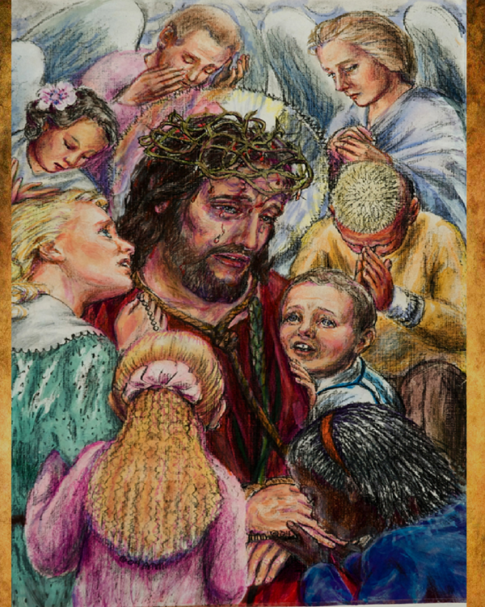
3rd Sorrowful Mystery
EUROPE – Pope Francis
“The 3rd Sorrowful Mystery: Jesus is crowned with Thorns.”
Fruit of the Mystery - Courage
“We are the children of the world, praying for Pope Francis, and peace in our families and the world.
In this Third Decade, we recall to mind the priests and families throughout Europe that they may grow in purity of mind, body and soul.”
Our Father… 10 Hail Mary's… Glory be… Fatima Prayer…
AVE, AVE, AVE, Maria...

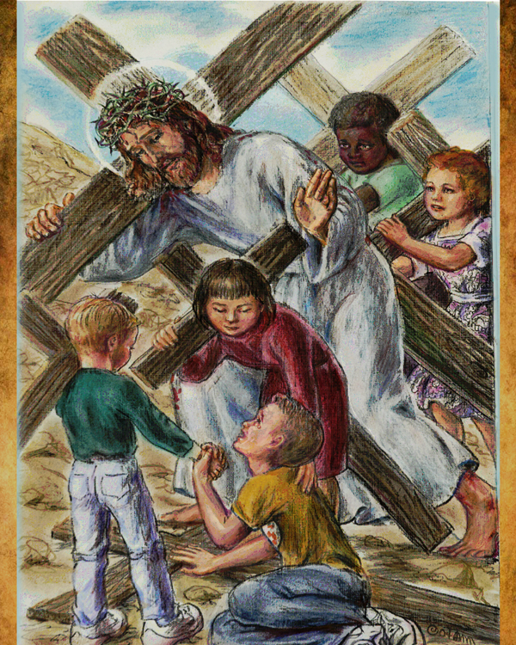
4th Sorrowful Mystery
OCEANIA -
The fruit of the mystery - Patience
“The 4th Sorrowful Mystery: Jesus Carries His Cross.”
“We are the children of the world, praying for Pope Francis, and peace in our and families and the world.
In this Fourth Decade, we recall to mind, the priests and families of Oceania, that they may grow in their love for the Immaculate Heart of Mary.”
Our Father…10 Hail Mary's… Glory be…Fatima Prayer
AVE, AVE, AVE, Maria...

5th Sorrowful Mystery
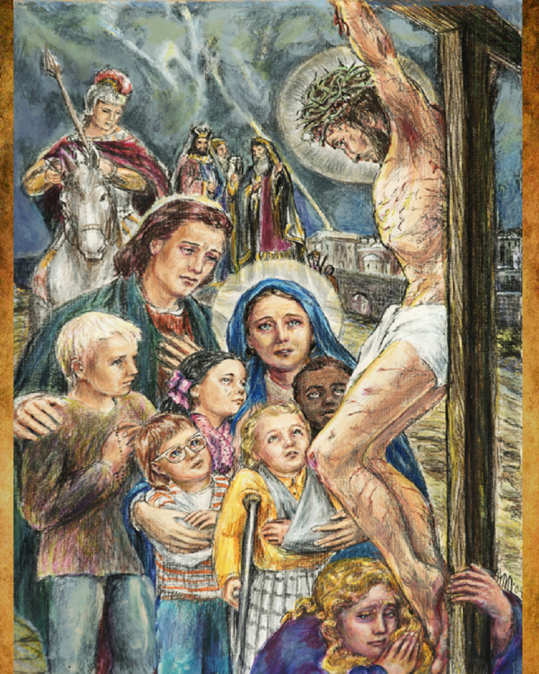
ASIA -
“The 5th Sorrowful Mystery: The Crucifixion and Death of Jesus.”

The fruit of the Mystery - Perseverance

“We are the children of the world, praying for Pope Francis, and peace in our families and the world. In this Fifth Decade, we recall to mind the priests and families throughout Asia that they may grow in holiness.”

Our Father… 10 Hail Mary's… Glory be… Fatima Prayer…

AVE, AVE, AVE, Maria...

Closing prayers of the Most Holy Rosary...

Thank you for participating in the 12th annual, Worldwide Children's Eucharistic Holy Hour.
Please begin a Little Shepherds Holy Hour in your parish, school and family.

In the Immaculate Heart of Mary
The International World Apostolate of Fatima
Board of Trustees of Children of the Eucharist, Young Missionaries of the Immaculate Heart of Mary: our prayer is that the souls of the children in your care will become active missionaries of the Immaculate Heart of Mary in their parishes, schools and families.

Litany

LITANY OF BLESSED FRANCISCO AND JACINTA

Lord, have mercy on us! Lord, have mercy on us!
Christ, have mercy on us! Christ, have mercy on us!
Lord, have mercy on us! Lord, have mercy on us!
Our Lady of the Rosary of Fatima, pray for us!
Our Lady of Sorrows, pray for us!
Our Lady of Mount Carmel, pray for us!
Virgin of the Little Shepherds, pray for us!

Blessed Francisco Marto, pray for us!
Blessed Jacinta Marto, pray for us!
Children called by Jesus Christ, pray for us!
Children called to contemplate God in Heaven, pray for us!
Little ones to whom the Father reveals the mysteries of the Kingdom, pray for us!
Little ones privileged of the Father, pray for us!
Perfect praise of the wonders of God, pray for us!
Perfect examples of filial abandonment, like children in the mother’s lap, pray for us!
Victims of reparation for the benefit of the Body of Christ, pray for us!
Confidants of the Angel of Peace, pray for us!
Custodians, like the Angel of the Fatherland, pray for us!
Adorers with the Angel of the Eucharist, pray for us!
Seers of the Woman dressed in the Sun, pray for us!
Seers of the Light that is God, pray for us!
Beloved children of the Virgin Mother, pray for us!
Ears attentive to the maternal solicitude of the Virgin Mary, pray for us!
Advocates of the Message of the Lady more brilliant than the Sun, pray for us!
Heralds of the word of the Mother of God, pray for us!
Prophets of the triumph of the Immaculate Heart of Mary, pray for us!
Accomplishers of the designs of the Most High, pray for us!
Faithful trustees of the Message, pray for us!
Emissaries of the Lady of the Rosary, pray for us!
Missionaries of the requests of Mary, pray for us!
Couriers of the calls from Heaven, pray for us!
Protectors of the Vicar of Christ, pray for us!
Confessors of heroic life in the truth, pray for us!
Comforters of Jesus Christ, pray for us!
Examples of Christian charity, pray for us!
Servants of the sick and the poor, pray for us!
Repairers of the offenses of sinners, pray for us!
Friends of men before the throne of the Virgin Mary, pray for us!
Pure white lilies breathing holiness, pray for us!
Brilliant pearls in splendid beatitude, pray for us!
Seraphim of love at the feet of the Lord, pray for us!
Offerings presented to God to bear sufferings for reparation, pray for us!
Admirable examples of sharing with the poor, pray for us!
Untiring examples of sacrifice for the conversion of sinners, pray for us!
Examples of fortitude in times of adversity, pray for us!
Souls enamored of God in Jesus, pray for us!
Little Shepherds leading us to the Lamb, pray for us!
Disciples of Mary’s school, pray for us!
Questioners of mankind, pray for us!
Fruits of the tree of holiness, pray for us!
Gifts to the Universal Church, pray for us!
Divine signs for God’s People, pray for us!
Witnesses of God’s grace, pray for us!
Incentives to living one’s Baptism, pray for us!
Examples of the experience of the loving presence of God, pray for us!
Eloquent souls in the intimacy of God, pray for us!
Intercessors, before God, for sinners, pray for us!
Builders of the Civilization of Love and Peace, pray for us!
Lamps illuminating mankind, pray for us!
Friendly lights illuminating multitudes, pray for us!
Lanterns shining on men’s roads, pray for us!
Flames burning in somber and anxious hours, pray for us!
Candles lighted by God, pray for us!

Christ, hear us! Christ, hear us!
Christ, please hear us! Christ, please hear us!

Concluding prayer:
God of infinite goodness, You love the innocent and exalt the humble; please grant, through the intercession of the Immaculate Mother of Your Son, that, in imitation of Blesseds Francisco and Jacinta, we may serve You in simplicity of heart and thus may enter the Kingdom of Heaven. Through Our Lord Jesus Christ, Your Son, Who is God with You in union with the Holy Spirit. Amen!

IMPRIMATUR: Most Reverend Bishop Antonio Marto of Leira-Fatima - Portugal
February 20, 2012

Rite for the Blessing and Investiture of the Scapular of Our Lady of Mount Carmel

To obtain the fullest possible benefits from the Brown Scapular devotion, one must be validly invested (sometimes called "enrolled") in the Brown Scapular by a priest who possesses the faculties (usually a Carmelite, Dominican or Franciscan), using a scapular blessed by the same or any other priest. After proper enrollment in the Scapular, a person need not have subsequent scapulars blessed. Once enrolled you are enrolled until death. A Scapular Ritual for Priests, with the prayers of enrollment, is found below:
Priest - Show us, O Lord, Thy mercy.
Respondent - And grant us Thy salvation.
P - Lord, hear my prayer.
R - And let my cry come unto Thee.
P -The Lord be with you.
R - And with your spirit.
P - Lord Jesus Christ, Savior of the human race, sanctify by Thy power these scapulars, which for love of Thee and for love of Our Lady of Mount Carmel, Thy servants will wear devoutly, so that through the intercession of the same Virgin Mary, Mother of God, and protect against the evil spirit, they persevere until death in Thy grace. Thou who liveth and reigneth world without end. Amen.

The Priest does the Aspersion and Invests Person(s) While Saying:

Receive this blessed Scapular and ask the Most Holy Virgin that by Her merits, it may be worn with no stain of sin, protect you from all harm and bring you to everlasting life. Amen.

After the Investiture the Priest Continues With the Prayers:

I, by the power vested in me, admit you to participate in all the spiritual benefits obtained through the mercy of Jesus Christ by the Religious Order of Mount Carmel.
In the name of the Father+and of the Son+and of the Holy Ghost+. Amen. May God Almighty, the Creator of Heaven and earth, bless you, He who has deigned to join you to the confraternity of the Blessed Virgin of Mount Carmel; we beseech Her to crush the head of the ancient serpent so that you may enter into possession of your eternal heritage through Christ our Lord.
R - Amen.

Investiture of the Medal of the Immaculate Conception

“Have a Medal struck according to this model, those who wear it after being blessed shall receive great graces,
especially if they wear it around their neck. Graces will be abundant for those who have confidence. "
Our Lady to St. Catherine Laboure
November 27th ~ 1830

Priest: Our help is in the name of the Lord.
Response: Who made heaven and earth.
Priest: The Lord be with you.
Response: And with thy spirit.
Let us pray.
Almighty and merciful God! In virtue of the many apparitions on earth of the Immaculate Virgin Mary, it has pleased thee to work miracles again and again for the salvation of souls. Be thou gracious and pour out Thy blessing X upon this medal, so that all who piously reverence it and devoutly wear it may experience the patronage of Mary Immaculate and obtain mercy from thee. Through Christ our Lord. AMEN
Then he sprinkles the medal with Holy water and presents it to the person saying:
Receive the holy medal, wear it with faith, and handle it with becoming devotion, so that the most Holy and Immaculate Queen of Heaven may protect and defend thee. And as she is ever ready to renew her wondrous acts of kindness, may she obtain for thee in Her mercy whatsoever thou dost humbly ask of God, so that both in life and in death thou canst rest securely in her motherly embrace. Amen.
He continues:
Lord, have mercy on us. Christ have mercy on us. Lord, have mercy on us.
Our Father
Priest: And lead us not into temptation.
Response: But deliver us from evil.
Priest: O Queen conceived without original sin.
Response: Pray for us.
Priest: O Lord, hear my prayer
Response: And let my cry unto thee.
Priest: The Lord be with you.
Response: And with thy spirit.
Let us pray.
O Lord Jesus Christ, Who hast willed that thy Mother, the Blessed Virgin Mary conceived without sin should be made illustrious through countless miracles, do thou grant that we who constantly invoke her patronage may come to possess everlasting joys. Who livest and reignest throughout endless ages. AMEN

PRAYER FOR THE CONSECRATION
OF THE FAMILY
Sacred Heart of Jesus and Immaculate Heart of
Mary, I come to you to consecrate myself and my
entire family to your Two Hearts. I desire to renew
the vows of my baptism and place each member of
my family through and act of faith, hope and love into
loving union with the Holy Family of Jesus. Mary
and Joseph. I dedicate myself and each member
of my family to the Guardian Angels God has
given each one of us. O Holy Guardian Angels,
enlighten, guide and protect each one so
as to lead us safely home to heaven.
At Fatima, dear Mother of God, you appeared with
St. Joseph and the Child Jesus blessing the world.
O Holy Family, bestow blessings upon me and my
family so that we may live the Christ-life.
I desire that each member of my family adore
always the Most Blessed Trinity and love our
God in the Most Blessed Sacrament.
Grant peace to each member of my family.
Keep each one in the grace of Jesus Christ. Never
permit any of my family to stray from the true faith.
(For any family member who has strayed, I beseech
you to bind up the wounds, lift up the fallen, restore
and keep each of our loved ones in grace. Bid them
come back to their Father's true home.)Amen

