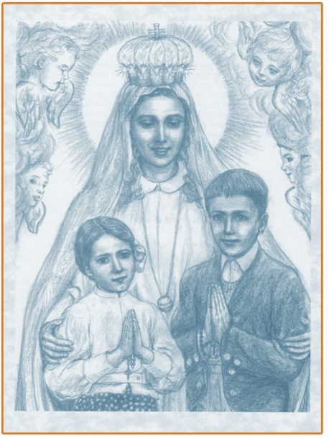
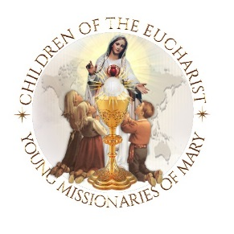

Prayer to Saint Francisco and
Jacinta Marto for the families of the world!
Dear Saint Francisco and Saint Jacinta,
The children of the world would like to learn from you how to love
more perfectly.
Saint Jacinta, teach us how to love one another, especially sinners.
Help us to pray and to make sacrifices for those who offend Our Lord
so deeply.
Saint Francisco, teach us your great love for the Sacred Heart of JESUS in
the Holy Eucharist, hurt by the ingratitude of so many.
Little Shepherds of Fatima, help me, my family, and all the
families of the world, to seek the safety of the Immaculate Heart
of our Mother MARY, who always brings all of us and our families
closer to Her Son JESUS.
Saint Francisco and Saint Jacinta, pray for us, pray for all the
children and families of the world! Amen

