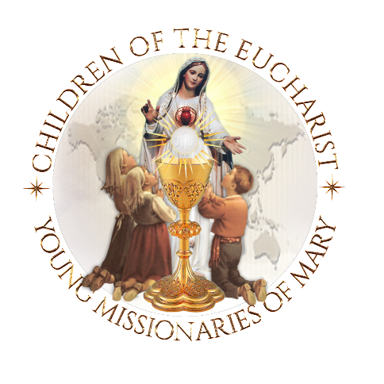
15th annual Worldwide Children’s
Eucharistic Holy Hour
Participate in the following (short) program for ‘spiritual unity’ or include the optional additional devotions such as beautiful procession, crowning etc.

Short program for spiritual unity
- Gather the Children before the Most Blessed Sacrament
- Jesus exposed in the Sacred Monstrance OR Tabernacle
- Light a 'Candle as a sign of Spiritual Unity'
- Explain to the children that they are united around the world
- Pray the 'Prayers of Reparation' to ‘console the Sacred Heart of Jesus, as taught to the Little Shepherds of Fatima, by the Angel of Peace
- Pray the 'Entrustment Prayer' to the Immaculate Heart of Mary
- Pray to Saint Francisco and Saint Jacinta for the families of the world
- Pray the World Mission Holy Rosary for the families of the world
OPTIONAL
- Procession and Crowning of Our Blessed Mother’s statue
- Investing our worlds under the protection of our Immaculate Mother.
- Please visit: http://www.childrenoftheeucharist.org/wear-a-sign-of-entrustment
- Investiture in the Brown Scapular or
- Investiture in the Miraculous Medal –
Click here for the prayers in a word document, for you to cut, copy and paste, to create your own program for the children.
Click here for additional information on Holy Hour
Click here for additional information for the broadcasting of the Holy Hour
Many of these prayers fulfill the requests of the Angel of Peace and of Our Lady of Fatima.

