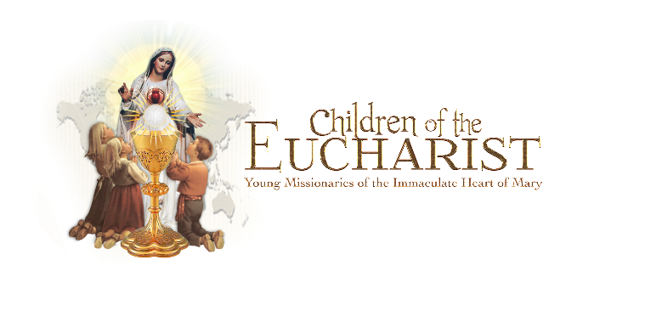
‘

Dear Parents,
I am excited to let you know that our classroom will be piloting a New Evangelization program for our school children and their families called The School of the Immaculate Heart of Mary – Five Steps to Holiness.
This program has been developed by Children of the Eucharist, Young Missionaries of the Immaculate Heart of Mary, a children’s spiritual formation program of the International World Apostolate of Fatima.
This program will focus on the message of Our Lady of Fatima. The Blessed Mother appeared to 3 Shepherd Children in 1917 asking them if they would help her win souls for Jesus by their prayers and sacrifices. Her message was for all children.
We will begin by watching a video about the story of Fatima, and then listen to a CD, Our Lady’s Call, about the visits of the Angel of Peace to the Shepherd Children. This will prepare the children for the signing of a Promise Card that they intend to help Our Lady bring the world back to God by means of their Eucharistic Adoration, Prayers and Sacrifices, as did the Little Shepherds. Their names will be flown to Fatima, Portugal, where Our Lady appeared six times to the Little Shepherds.

The School of the Immaculate Heart of Mary consists of the Five Easy Steps to Holiness:

1. The first week we will learn a “Morning Offering” prayer to say each day. We will also be learning the “Sacrifice Prayer” taught to the Little Shepherds by Our Lady, to say each time we make a sacrifice. We will be making and wearing ‘Sacrifice Bracelets’ and keep track of our sacrifices on our ‘Treasure Sheets’ as part of an ‘Offer It Up!’ campaign. All these things will help us focus on making sacrifices to help Our Blessed Mother bring peace to our families and the world.
2. Visits to Jesus in the Blessed Sacrament – Our classroom will begin making weekly visits to Jesus in the Adoration chapel.
3. Consecration/Entrustment to Mary – Entrustment to the Immaculate Heart of Mary is an important part of the spiritual life every Christian. We will learn how and why Mary’s spiritual motherhood is the key to developing holiness in our character and actions.
4. Wearing the Brown Scapular or Miraculous Medal – We will learn the history and importance of the Brown Scapular and the Miraculous Medal.
5. Rosary – We will learn how to pray the Rosary and the importance of saying it often.
I will be forwarding to you the prayers we learn along with any information I have regarding our lessons each week so you can incorporate them into your family life if you wish.
Peace, Teacher

